Math 1 Name __________________________________
Lesson 1-4 Average Rate of Change HW Date_________
- Find the average rate of change between the following points. (-2,5) (8,-1)

- Sammie’s savings account balance changed from $1,450 in January 2014 to $3030 in May 2014.
  - What would be the independent and dependent variables in this problem?

  - Find the average rate of change per month. Round your answer to the nearest dollar.

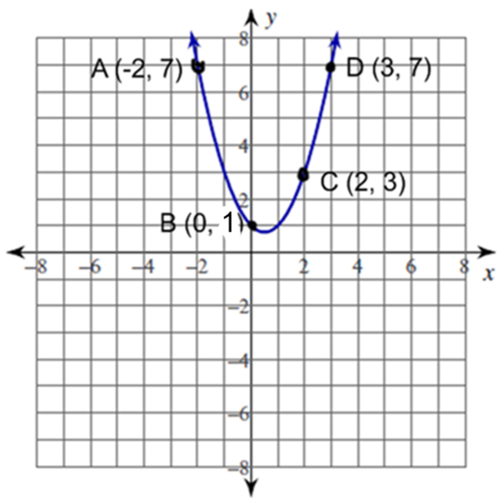
- Find the average rate of change from A – B.
Describe the pattern of change.

- Find the average rate of change from A – C.
Describe the pattern of change.

- Find the average rate of change from A – D.
Describe the pattern of change.

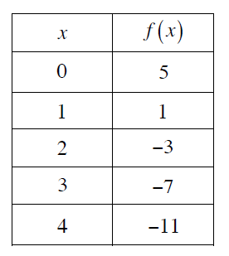
- Using the table, find the average rate of change from x = 1 to x = 4.

